Continue to Fast - Spiritual War Zone
September 4, 2017
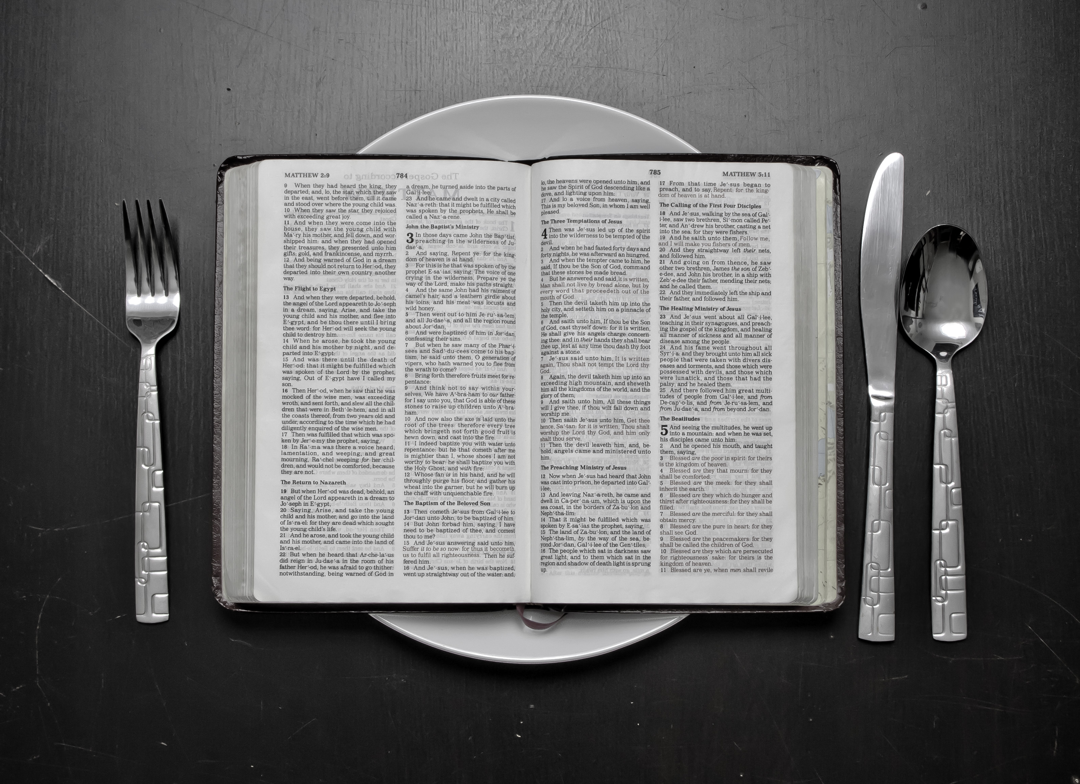
I pray for all of us, dear Heartdwellers, that each day we will choose to conquer our flesh and serve the Lord more faithfully. Amen

Well, I blew it today. I broke a fast, not taking the time to discern if it was permissible for me to do so. The Lord was silent after communion so I came here and sat down, asking Him, “Lord, is there something You want to say?”

He answered me, "You broke your fast."

Lord, I thought you brought up the Sunday provision—a day of rest?

And that's true. I was here in soaking prayer, dwelling prayer, and I really felt the Lord—possibly the Lord—urging me to go and get some coffee and get ready for a night of work. And that it was okay to have a biscotti. Because it's Sunday. A day of rest. But...apparently not.

He answered me, "Not for this fast."

He didn't give me permission to break the fast on Sunday, because it's a day of rest. He said, "Not for this fast. It is too critical."

I opened the Bible Promises to get a confirmation—and I turned to Lust.

Sigh... “What do I do now except put the Biscotti away, Lord?”

"Find a way to make it up to Me."

Okay. No butter?

"Well, that’s a start. That works."

Please, forgive me Lord.

"I forgive you, but next time ask your covering before you vaulting off.

"You are in a war zone, Clare. You have many enemies and they are doing their best to bring you down. I will not allow it if you follow My directives, even as I have taught you before. Brotherly Love. They will try to create enmity and infighting. Stay in brotherly love at all times and no matter what it looks like, be loving and lenient. You cannot win this battle alone; that is why you saw the warrior angel at the sign of peace. He told you, you are in a battle."

And that's exactly how it happened. At the sign of peace, a very large warrior angel came up to me and said, "Whoof! You're in a BIG spiritual battle!" I was oblivious to it.

And today Ezekiel got a Rhema message from the Heartdwellers web site and it was all about brotherly love and the Lord’s promise to protect us if we continue to be loving, forgiving, patient and kind with everyone.

Well, I have to admit, I have been struggling for two days now with the heat, and little things here and there. Things that should have been handled more responsibly—but were ignored and caused a waste of time as well as a near accident. I got angry about these things, although I didn’t tell the parties responsible. I have calmed down, but now I see there is a war going on to injure the core group.

And Jesus has been warning me for days that there is also a Judas, a betrayer among us. I’m just praying for the strength to forgive and keep being faithful to you, my dear Heartdwellers.

Jesus continued, “Vigilance is of the utmost importance right now. Do nothing hastily and do not rebuke in anger. Wait until you have cooled down, mention it with gentleness and then let it go. They are little things, Clare. Yes, I know they cause you extra work because certain ones can be sloppy. I understand. But just as a penance for Me, try to take it better and offer the inconvenience to Me for the world condition."

Well, today I was praying the Divine Mercy Chaplet and I saw Jesus with the crown of thorns suffering terribly on the Cross. It was not easy to see. I also got off track a couple of times today and wasted time. Now, at the end of the night, I am so tired. I don't know if I can stay away to do what is really important.

Jesus broke in and said, "Beloved, be more self-controlled and vigilant. For the most part, you are doing way better, but improvement can be made. You are doing well, My Love. Cooperate with Me to do better?"

Yes, Lord.

"You see, so much hinges on how well you do now. Your faithfulness to music. I have opportunities planned for you but you must be ready. You need to be more strict with yourself—you are too passive. You allow circumstances to dictate to you what will get done and what will not get done. This is not good. You need more discipline and prioritizing. And that needs to start tomorrow.

"It doesn’t look like much to you now. When you don’t quite make all the time you should for practice you say, 'Oh, I’ll catch up tomorrow.' And look at your tomorrow—which was today—and still you are not practiced. And you are tired at this point, ready to go to bed. You are wasting time, My love, still too bound up in trivia. I know some of the things you did were important, but others were unnecessary. Please, Clare, be more self-aware and correct yourself. Heed My voice when I prompt you, 'You’re wasting time…'

"I am giving you more time, but you are wasting it. It feels good to be able to sit down and relax and read a few things, or listen to a Youtube, because they catch your attention, your curiosity."

That happens every time I put a film up, every time I put a Youtube up. There's something that really grabs your attention. Like the hurricane thing that's going on. And... I just shouldn't have looked at it.

And the Lord continued, and He said, "And these were arranged by the enemy to do just that. To pull you off track and waste your time. Like that huge urge for chocolate. Where do you suppose that came from?"

A masquerading spirit?

"That’s correct. And you fell for it. You wanted that cookie, so you didn’t discern properly. There are many such traps set up for you during the day and you’ve been lagging behind and falling for some of them. Others you've seen - and you've sidestepped them. And for that I am very grateful.

"You need to be more detached in looking at your own behavior. I need you to spot your weak points, be aware of them and anticipate a trap from the enemy. They will always play on your desire for something—that’s the easiest way to distract you. Whether it be for a neater house, or something to eat, or something to read... They will play on your desires.

"What Ezekiel told you was very relevant."

Well, tonight Ezekiel and I were talking about a saint of the eastern church - because as I was having a communion service, I saw him at the sign of peace. And this happens frequently with saints that I've already been in Heaven with, and I've already met. This was St. Charbel, who lived in a monastery. And they used to say, “When tempted to do something, consider Heaven.” St. Francis used to say, “Ask Sister Death.”

In other words, when you stand before the Father in Heaven, will you be ashamed if you give in to this temptation? If you will—then don’t do it. Envision yourself standing before God and having to give an accounting for this sin, or indulgence. This will help you not to do it.

Lord, help us.

"Yes, I will, if you are listening very carefully. But one tends to get deaf around the aroma of warm chocolate cookies. You can do better, My Love, you really can—and you almost did. But you were tired and you reasoned, 'This is Sunday and I always have the freedom from fasting on Sunday.'

"But you didn’t ask, or I would have told you, 'No. This is too critical. Continue to fast.'

"You see, the enemy knows that, and he sent in a temptation to make you fall. But I have reinstated you on your word to give up another indulgence. And this time, you won’t be so foolish. I will tell you when the fast can end."

Jesus continued, “Well, for all of you who consider yourselves a part of this ministry, I have asked you to give up things. For the older ones among you, sacrifice things you enjoy. For the younger, bread and water or rice and water and tea or coffee is permitted. Some of you cannot pray without it. If you cannot fast on bread and water, use peanut butter & honey on bread and eat it one meal a day, during the day with two snacks. This is a good, healthy fast. The meal should not be your favorite or something you really enjoy—make it very simple.

"These are powerful offerings, My people, truly they are. That is why Satan has sown so much confusion about them—to keep you from making any sacrifices. But I have told you, your fasts and prayers are powerful. So, do not let the enemy talk you out of it.

"If you are at an occasion where there is a celebration meal, do not tell others about your fast. Rather, discretely eat very little of the food and most will not even notice you are not eating. In fact, on every offering that you make, keep it hidden, lest you receive your reward down here like the Pharisees who loved to be noticed when they fasted and prayed. Parading your penances and gifts to Me before men also leads to Pride. So keep them secret between us."

As an aside on that, St. Francis used to drop the food into a napkin on his lap and later feed it to the beggars that came to the door.

And I just remembered, a Daniel fast, rice and vegetables, is also a good offering that the Lord has accepted in the past.

Jesus continued, "My People, your prayers are working. DO NOT STOP NOW. We are still at a critical juncture. Why do you suppose these hurricanes are so devastating? All the loss that others suffer cries out to Heaven and they, too, are joining Us with these things. Though they are not aware of it in their intellect, in their spirit it is understood. This IS a sacrifice to prevent the beginning of the War and the Tribulation.

"How blessed you will be if you do these things. I am with you. Call on Me frequently for My help. I am here for you."

